

|  |  |
| --- | --- |
| ***Group member names*** | ***Group member ID*** |
| Muhammad Hamza | 1593756 |
| Muhammad Burhan | 1605741 |
| Muhammad Ahsan Raza | 1593769 |
| ---- | ****** |

***Batch number PR2-202408E***

# ***Certificate of Completion***

This is to certify that **Muhammad Hamza , Muhammad Burhan, Muhammad Ahsan Raza** and  
have successfully completed their HDSE Semester I e-Project.

Submitted to: **Aptech Computer Education**

On

**January 6th, 2025**

# ***Acknowledgement***

First of all we would like to thank Almighty ALLAH for giving us strength and ability to complete this project.

And then, we would like to express my special thanks of gratitude to our teacher ***Sir Talha* *Khan*** who guided us on the project*Insurance*, which also helped us in doing a lot of new learning and we came to know about so many new things we are really thankful to him.

We are highly thankful to ***Sir Talha Khan*** for his guidance and constant supervision as well as for providing necessary information regarding the project & also for his support in completing the project.

Lastly, we would also like to thank our parents and friends who helped us a lot in finalizing this project within the limited time frame. We also express our sincere gratitude to E-Project team from Aptech Head Office, for their valuable guidance and support for the completion of this project. We earnestly hope that this project will provide all the necessary information required by the user to fulfill his/her inspiration. However, suggestion and Feedbacks for improvements will be thankfully welcomed & acknowledged*.*

# ***Project Synopsis***

**TrustGuard** is a leading insurance company, renowned for offering comprehensive coverage plans, from life insurance to property and health policies. The company provides a wide range of affordable, flexible options tailored to meet the needs of modern-day consumers. **TrustGuard** has experienced significant growth and customer satisfaction, securing impressive profits in 2023.

To further enhance its reach and services, we are developing a user-friendly website for **TrustGuard**. This platform will provide easy access to policy information, streamlined claims processing, and personalized insurance recommendations, ensuring customers can manage their coverage with ease. The new website aims to support the company’s continued success and growth in a competitive market.

# ***Problems Statement:*** Safe Carz Limited is into providing insurance cover for Cars and other vehicles. They provide various insurance policies through different Insurance companies. They now want to provide details of these insurance products on internet. They want to host a website with all the information about their organization and various insurance plans available with them. *Requirement Specifications*

The Web site is to be created based on the following requirements.

1) Home Page should contain logo of the site with proper sections and details of

various Insurance plans available.

2) The site should display a menu which will contain the options for brief

introduction about the various categories and plans available, location of the

shop and any other information if required.

3) The information should be categorized according to the company names of

the Insurance plans like if a User wants to see only “Zurich Insurance” plans

or any other company’s insurance plans then he/she can click on a

Link/button/menu etc and can see only that Companies plans .

4) Another category option for plans of different type of vehicles, like ‘Four

Wheelers’, ‘Two Wheelers’ etc. should be created and accordingly.

5) When a user selects any particular brand, a list of various plans for that brand

will be displayed

6) A brief summary about individual plans should be displayed on the Web Page

along with the base price.

7) There should be a “Contact Us” page which will have the Address of the Store

which is as follows and the mail address which when clicked will invoke the

local mail client from where they can send an email.

#Plan = Insurance Plan / Insurance Product

# ***Hardware and Software Requirements***

***Hardware:***

* A minimum computer system that will help you access all the tools in the

courses is a Pentium 166 or better

* 64 Megabytes of RAM or better

***Software:***

• Notepad/HTML editor/CoffeeCup

• Angular / Angular JS / React / BootStrap

• Dreamweaver / Figma

• MS IE / Chrome / FireFox / Netscape /MS Edge

# ***Architecture and Design of the System***

The application will have a client-server architecture.

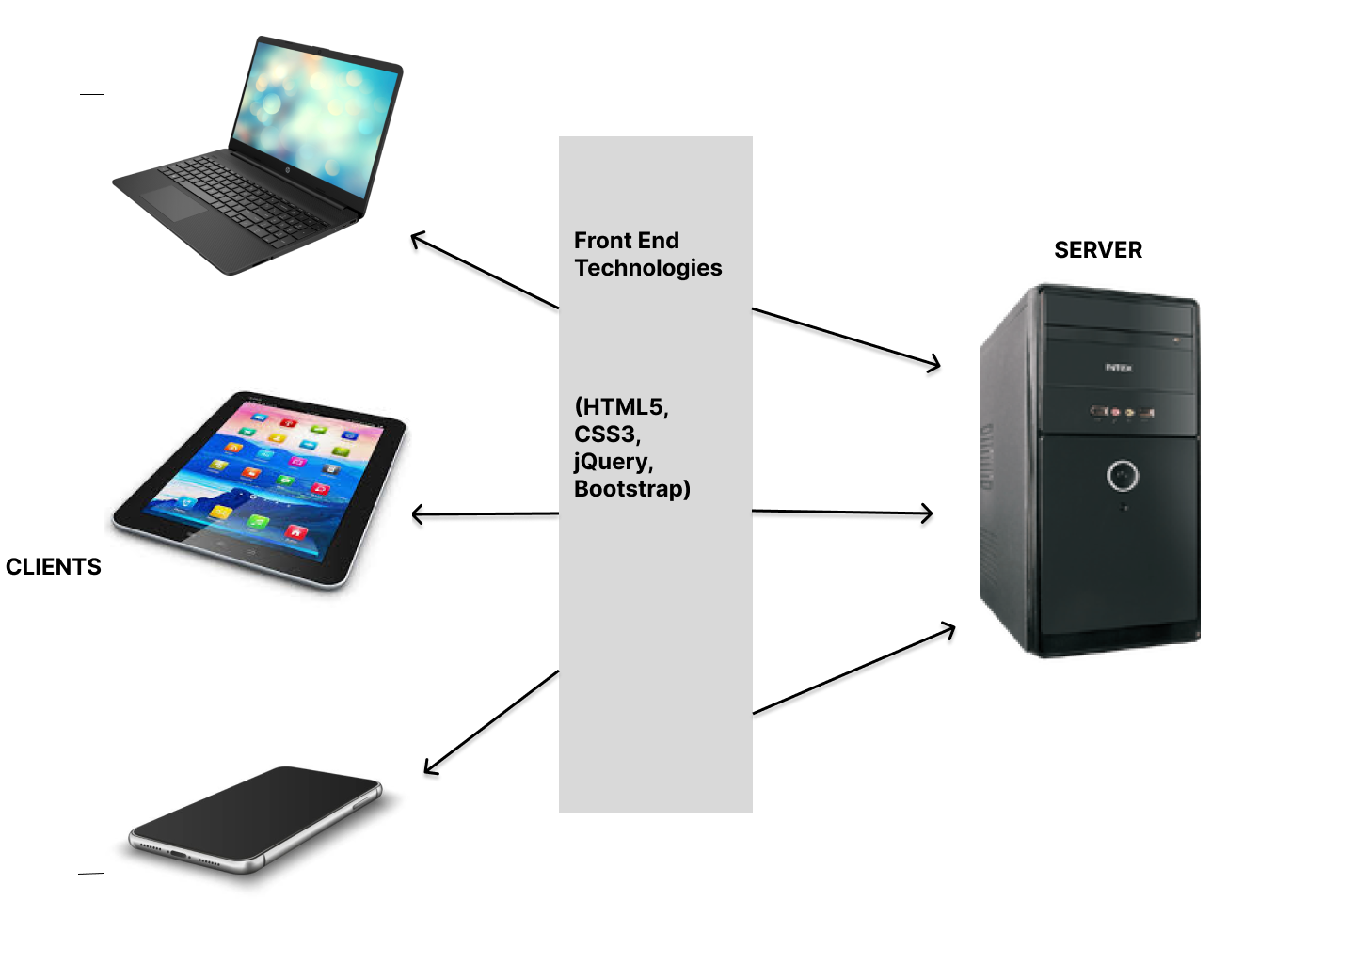

Client-server Architecture of the Project.  
  
  
***Site map***

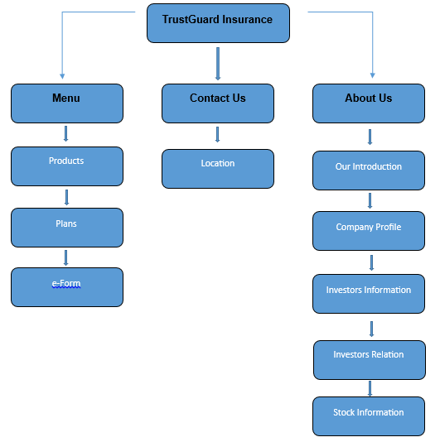

* ***MAIN NAVIGATIONS:***
* ***Insurance Products:***

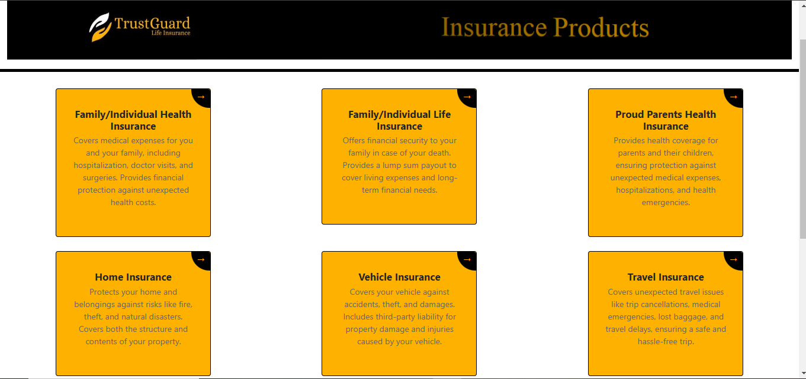

* ***Insurance Plans:***

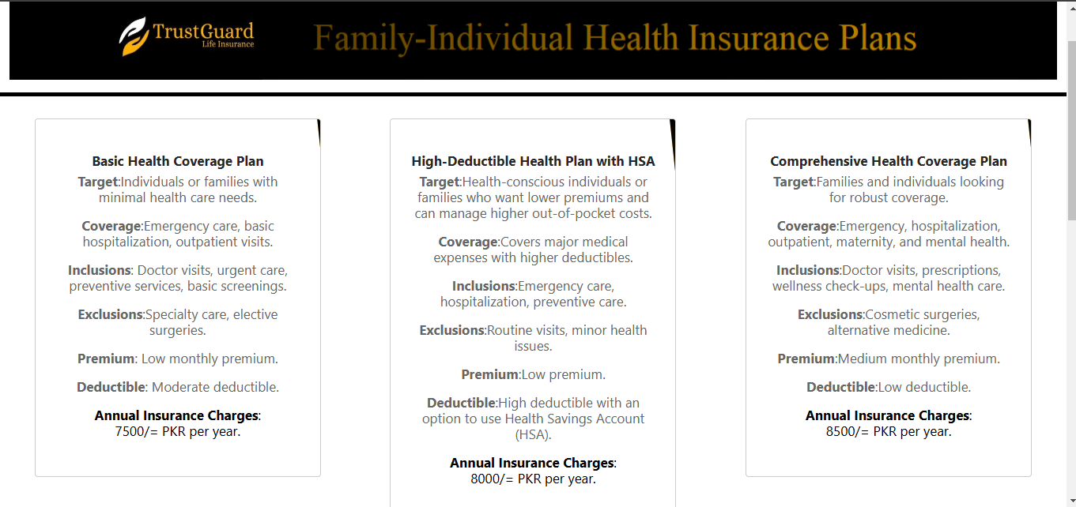

# ***Task Sheet***

|  |  |  |  |  |
| --- | --- | --- | --- | --- |
| **Project Ref. No.** | | **Project Title** | **Date of Preparation of Activity Plan** | |
| **S.No.** | **Task** | **Insurance** | **Actual Days** | **Status** |
| **1** | **Analysis** | **2** | **OK** |
| **2** | **Design** | **3** | **OK** |
| **3** | **Development** | **8** | **OK** |
| **4** | **Testing** | **2** | **OK** |
| **5** | **Documentation** | **1** | **OK** |